***Thomas Hudner/Devotion Event September 10, 2023***

**Registration Fee Payment & Processing:**

Name:  __________________________________________________________________________

Address: _________________________________________________________________________

City: ____________________________________________________________________________

State: _____    Zip: __________________      Phone:_____________________________________

Email: ________________________________________________________________

Checks made Payable To:   **Cathedral of the Pines**

Or Credit Card Info

Name on CCard:  _________________________________________________

Credit Card #:  _____________________________________________________________________

Exp. Date:  ______________     Billing Zip Code  _________

All Registration Forms **MUST** be filled out completely and include either a check or credit card payment info

Mail To:**Cathedral of the Pines 10 Hale Hill Rd.  Rindge, NH  03461**

**ATTN: Devotion Event**

________________________________________________________________________

***We look forward to having a fantastic day!***

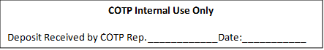Text Box

